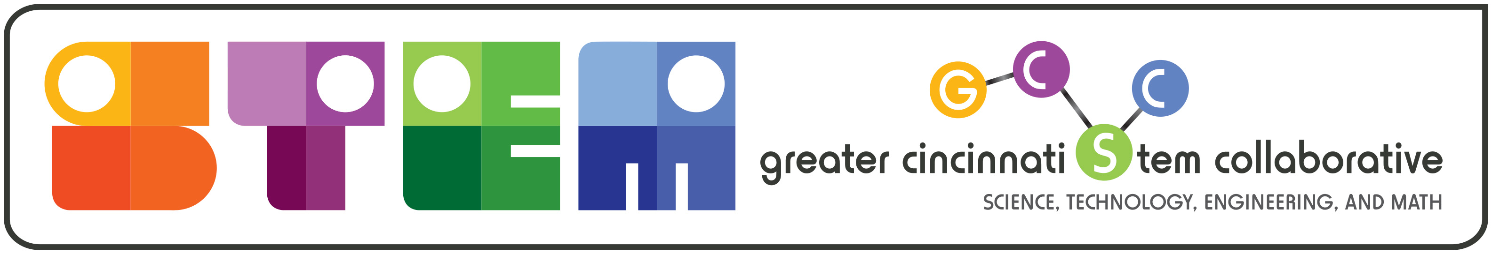
Effective STEM Experiences Rubric  Evaluation Guidelines: Accomplished - Major Focus, Consistent, Observable Evidence  Emerging - Minor Focus, Fine-Tuning, Refining  Limited - Early Development, Experimental Focus, Minimal Focus | Accomplished | Emerging | Limited | N/A
PROGRAM STRUCTURE
Problem and/or Project Based - a problem solved or project is designed during the experience; finding the solution involves hypotheses, testing, analyses, failures, redesign and iterations etc.
Comment:
Inquiry / Evidence based- investigations / trials are student centered, developed, implemented and priority is given to student observations and conclusions that are backed by empirical data/evidence.
Comment:
Real Life / Authentic - problem and/or solution is relevant to local and/or global community and examined through an overarching purpose/theme. (Big Idea)
Comment:
Student Driven - students are the main project planners and executers of the plan. Parameters can be set by the experience. (Student planning versus Adult directed)
Comment:
Advancement - opportunities for advancing to higher levels of experiences are based on meeting program specified criteria.
Comment:
Learning Environment - is altered or external location is part of the experience.

Comment:
Integrated Content
STEM - involves the integration of the four disciplines: Science, Technology, Engineering, and Math.

Comment:
Science - involves a primary focus on the physical sciences (physics, chemistry, earth sciences) and/or life sciences (biology, botany, zoology) and NGSS science practices.
Comment:
Technology - involves a primary focus on the selection and application of multiple technology tools and resources. (computer science, data programming, web design, hardware, software, and selection )
Comment:
Engineering - involves a primary focus on demonstrating thinking skills while applying the engineering design process and NGSS engineering practices.
Comment:
Math - involves a primary focus on the skills and application of mathematical practices.

Comment:
Interdisciplinary - aligned with content from non-STEM disciplines. (English/language arts, writing, social studies, art, music, etc.)
Comment:
21st Century Skills
Communication - provides opportunities to effectively articulate thoughts and ideas in a variety of ways (oral, written, non-verbal, digital, and including listening, presenting evidence, advocating ideas.), with diverse audiences
Comment:
Collaboration - involves team based work, that holds all accountable for being, respectful, responsible, while appreciating contributions of all.
Comment:
Critical Thinking / Problem Solving- involves effective reasoning, systems thinking, making judgments, decisions and solving problems.
Comment:
Creativity and Innovation - create, develop and implement new ideas; use variety of creation techniques; elaborate, refine, analyze own ideas to improve them.
Comment:
Student Impact
Inclusive Curriculum and Culture - designed to be engaging to populations typically underrepresented in STEM. (racial, gender, socio-economic, special needs, etc.)
Comment:
Creates Career Awareness - increases student awareness of the possibilities for their future STEM careers and education requirements.
Comment:
Adult Engagement
Adult Facilitators - adults are present to facilitate and guide student-centered activities as coaches and supporters of the experience.
Comment:
STEM Professionals - adult STEM professionals (retired, employed, or college students) serve as mentors, tutors, coaches or speakers during student-centered experiences, and include under represented populations.
Comment:
Program Evaluation / Assessment / Measurability
Quantitative Measures - establishes measures and tracks results of program effectiveness (grades, STEM skills, test scores, attendance, discipline referrals, etc.) broken out by age, race, gender, SES, special needs, etc.
Comment:
Attitudinal Measures - establishes measures and tracks results of program effectiveness on the participant attitudes (STEM Subjects, STEM Careers, further education, etc.) by age, race, gender, SES, special needs, etc.
Comment:
Student Action Oriented Decisions - tracks students decisions/actions post program (program of study selection, schools selection, career selection, additional education, graduation rates, etc.).
Comment:

You can find a Word file for the rubric at http://greatercincystem.org/new_stem_resources.php
You can use the on-line version at http://greatercincystem.org/new_stem_rubric.php

Purpose, Objectives, Scales and Directions
With the overall goal of increasing the number of students prepared for and interested in STEM studies and careers, the Greater Cincinnati STEM Collaborative has developed a rubric that provides a definition for “effective” STEM experiences. Engaging students in high quality STEM experiences is a proven tactic to meet our overall goal. Researching best practices across the country and tailoring it to meet the needs of our region developed the rubric.

